Week 3 practical

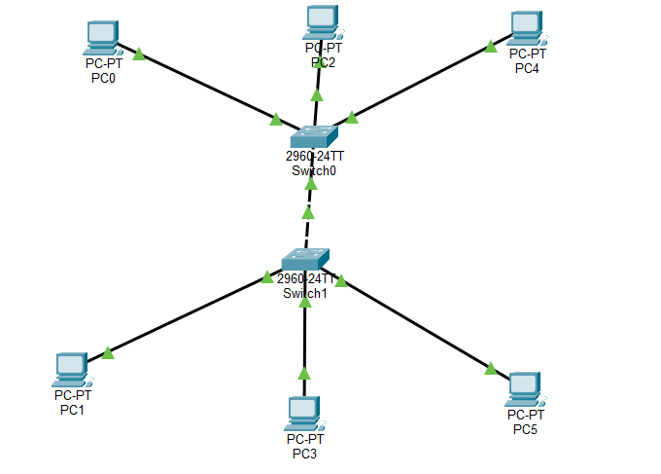

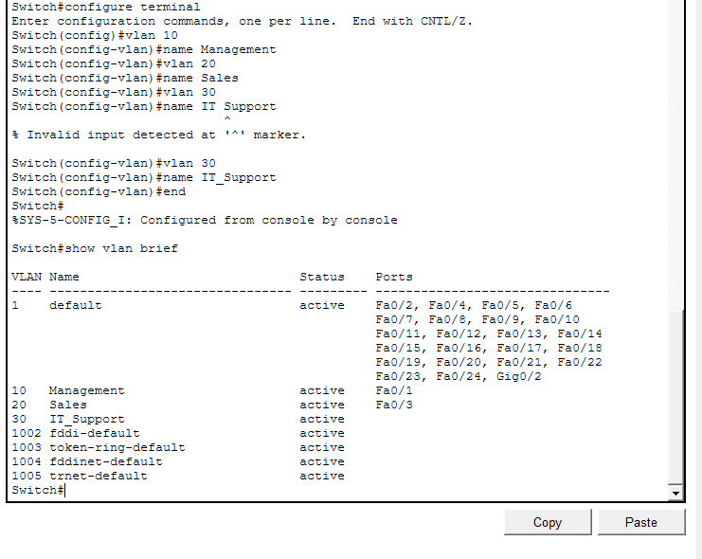
Switch 2

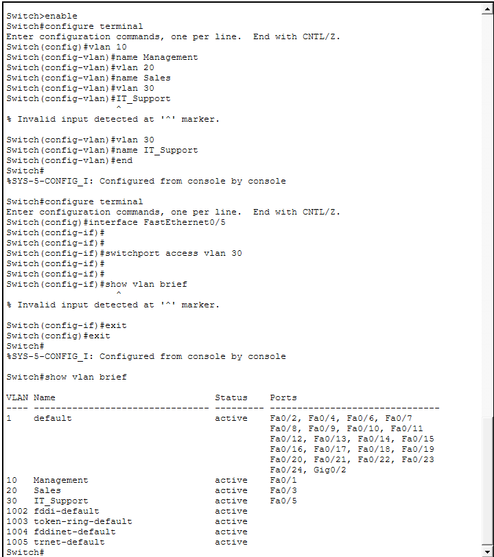
Switch 1

Task 2


Task 3

The native VLAN is the VLAN that carries untagged traffic across a trunk link. By default, this is VLAN 1.
Security implication: Leaving it at the default (VLAN 1) is risky because VLAN 1 is often used for management traffic. Attackers could exploit misconfigurations or VLAN hopping attacks if untagged traffic is allowed on VLAN 1. Best practice is to change the native VLAN to an unused VLAN and ensure VLAN 1 is not used for user or management traffic.

By default, a trunk allows all VLANs to pass. This can: Increase unnecessary broadcast traffic across the trunk.
Expose VLANs to parts of the network where they aren’t needed, which is a security risk.
Using the allowed VLAN list ensures only the VLANs required for communication traverse the trunk, reducing attack surface and improving efficiency.

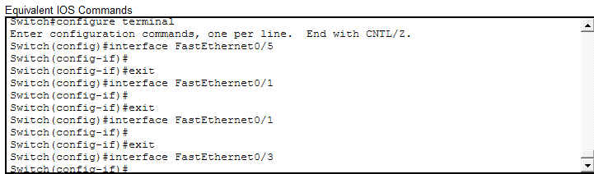

Task 4
Ping PC1 192.168.10.10 TO 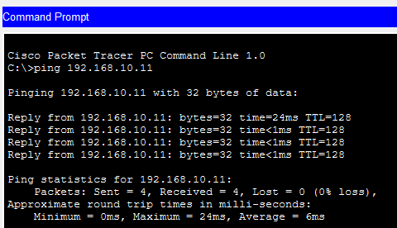 PC2 192.168.10.11

PC3 (192.168.20.10) To PC4 (192.168.20.11)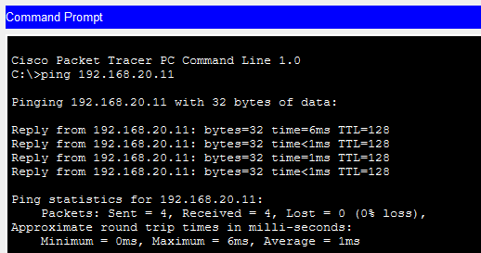

PC5 (192.168.30.10) TO PC6 (192.168.30.11)
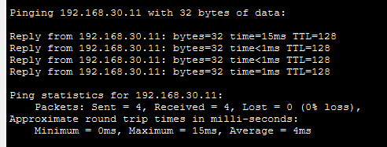

PC1 (192.168.10.10) TO PC3 (192.168.20.10)
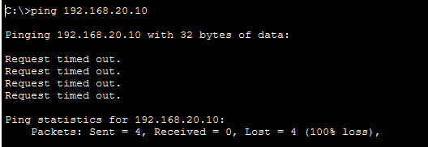
Each VLAN is treated as a separate broadcast domain.
To fix it, you need a Layer 3 device (router or Layer 3 switch) to perform inter-VLAN routing. Each VLAN must have a gateway IP address configured, and hosts must point to that gateway to reach devices in other VLANs.

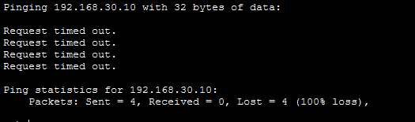

Task 5
PCO PC2 PC4
VLAN 10
VLAN 30
VLAN20

(VLAN30)
VLAN 20
VLAN 10

Fa0 Fa0/3 Fa0/5
FA1

SWITCH 1

Gi0/1 (Trunk)

SWITCH 2

Fa0/1 Fa0/3 Fa0/5

PC1 PC3 PC5

PC1 PC3 PC5

